**7.Arduino UNO Pi platform-------** **infrared_follow**

**1)****Preparation**

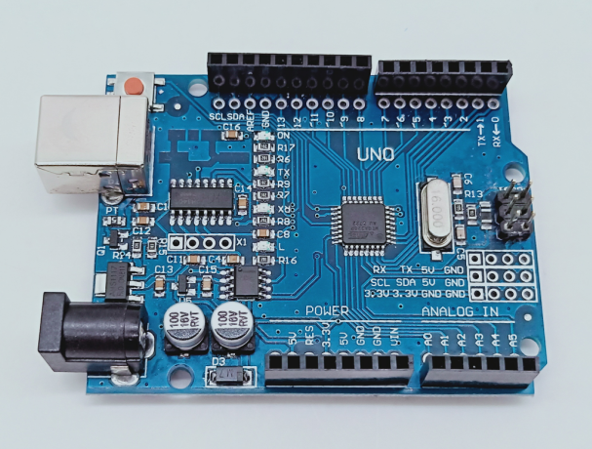

1-1 Arduino UNO board

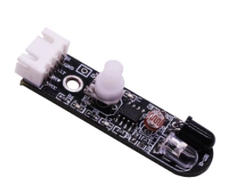

1-2 Infrared obstacle avoidance module

**2)Purpose of Experimental**

After the code upload is completed, You need to press the K2 to start the car, and the infrared follow function is started. When there is an obstacle in front, the car can follow the obstacle automatically.

**3)Principle of experimental**

The basic principle of the infrared sensor is to use the reflective nature of the object. Within a certain range, if there is an obstacle, the infrared rays will encounter obstacle and will be reflected to reach the sensor receiving pin. In this experiment, we used 2 infrared sensors connected to the Raspberry Pi board to detect the obstacles by detecting the electrical level of the two ports, and robot car will make corresponding follow actions.

**4)Experimental Steps**

4-1 About the schematic

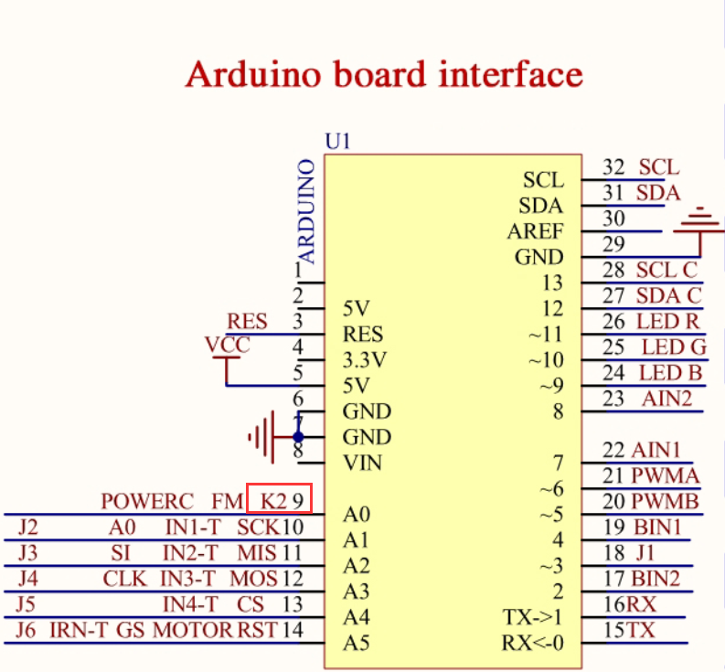

4-1 Arduino UNO interface circuit diagram

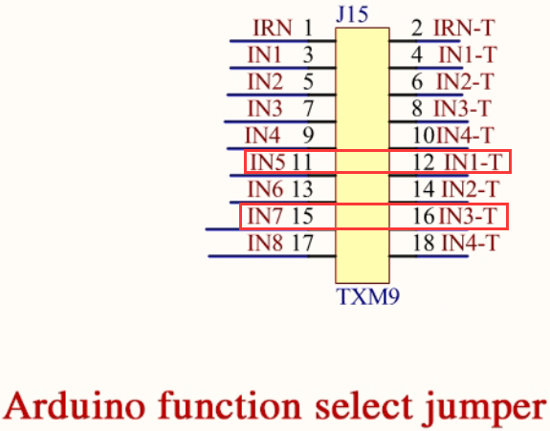

4-2 Arduino function select jumper

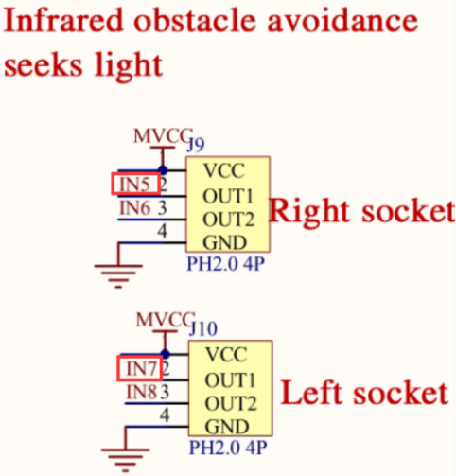

4-3 Left and right infrared sensor interface

4-2 According to the circuit schematic:

Left infrared sensor-----A3

Right infrared sensor-----A1

(Note: We use the wiringPi library to write code.)

（Note: In this experiment, we can adjust the sensitivity of the infrared follow module by rotating the potentiometer on the infrared module to achieve better experimental results.）

4-3 About the code

1. We need to open the code of this experiment:**infrared_follow.ino**, click“**√**” under the menu bar to compile the code, and wait for the word "**Done compiling** " in the lower right corner, as shown in the figure below.

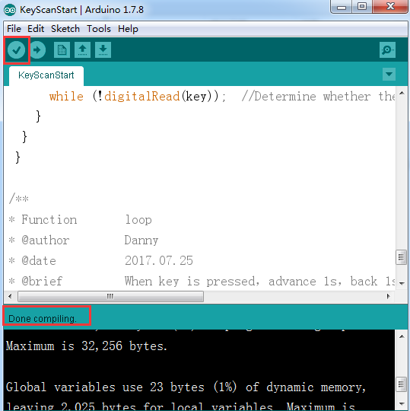

2.In the menu bar of Arduino IDE, we need to select 【Tools】---【Port】--- selecting the port that the serial number displayed by the device manager just now, as shown in the figure below.

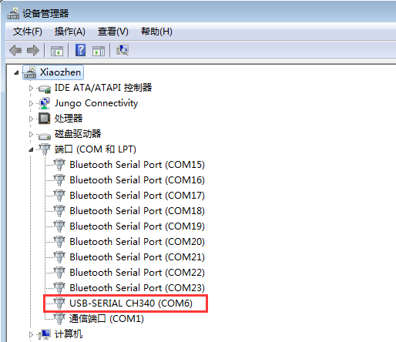

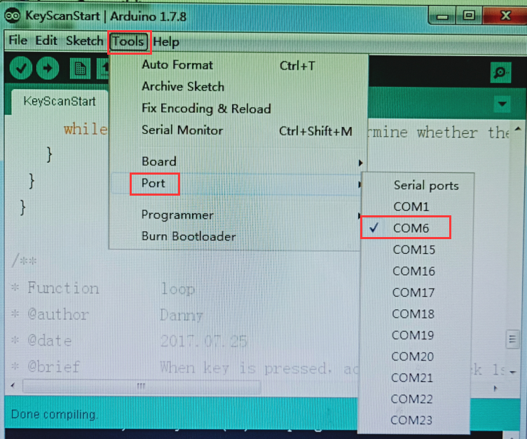

3.After the selection is completed, you need to click “**→**”under the menu bar to upload the code to the Arduino UNO board. When the word “**Done uploading**” appears in the lower left corner, the code has been successfully uploaded to the Arduino UNO board, as shown in the figure below.

